DRAWING TREND-LINES

Welcome to a very important lesson needed for a successful forex trading- TREND-LINES.
VFA seeks to show you here How to draw a valid Forex trend line, what it is used for, and many other things Forex traders should know about.
Trend line helps to identify main price direction during a certain period of time.
If placed correctly it will provide answers to:
Where to enter the market?
What direction to enter: up or down?
When to exit or be prepared to exit?
So, starting with a plain candle stick chart graph
Fig. 1: plain price chart of EURUSD
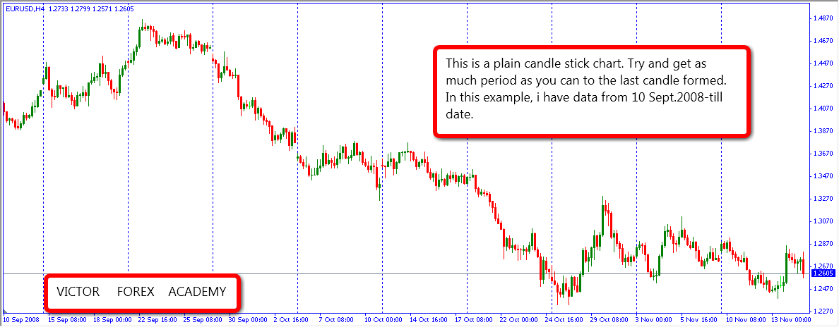

Trends are made up of waves. We have the High and the Low points.

In an uptrend, we’ll have the HIGHER HIGH (HH) and the HIGHER LOWS (HL). So, if a wave is making HH and HL, you know it’s an uptrend and you seek to plot your trend line joining the low end of your points.
See Fig. 2

Fig. 2: HH and HL points on an uptrend wave

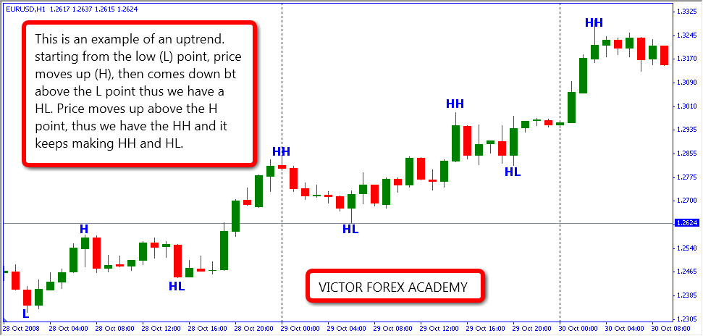

In a downtrend, we have the LOWER LOWS (LL) and the LOWER HIGHS (LH). If it is making a LL and LH, you know it’s a downtrend and you seek to plot your trend line joining the high end of your points. See fig. 3

Fig. 3: LH and LL points on a downtrend wave.
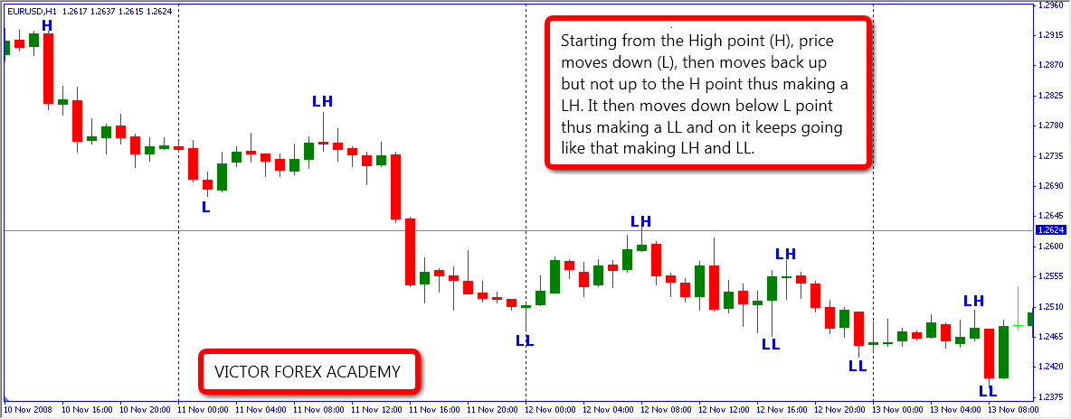

Several important points on a chart help us to draw a trend line in Forex.
We call these points A-B-C-D points.

Fig. 4: ABCD points (the high and low points)
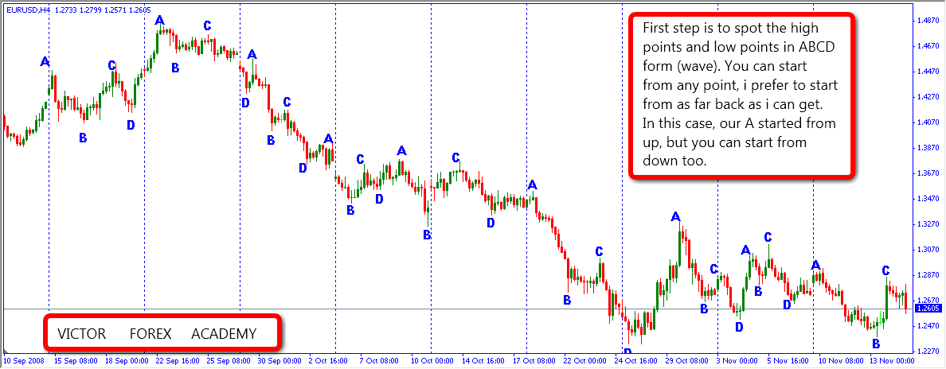
Some do have the initial difficulty of spotting the highs and lows of a wave, to solve this, use the zig-zag indicator with a setting of 5, 3, 3. See an example below
Fig. 5: The Zig-Zag indicator
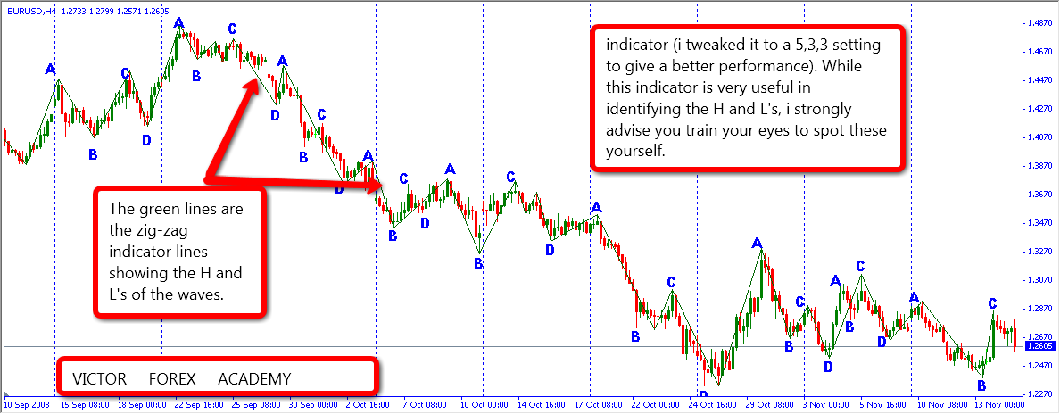

Having identified the HH, HL points in an uptrend, and the LH, LL points in a downtrend, simply replace these points with ABCD.
In Fig. 2, L=A, H=B, the first HL=C, the first HH=D. Now draw a line to join A to C and there you have a perfect up trend line. See Fig. 6. (Let it extend beyond C and see what happens to price at trend line points.

Fig. 6: up trend line
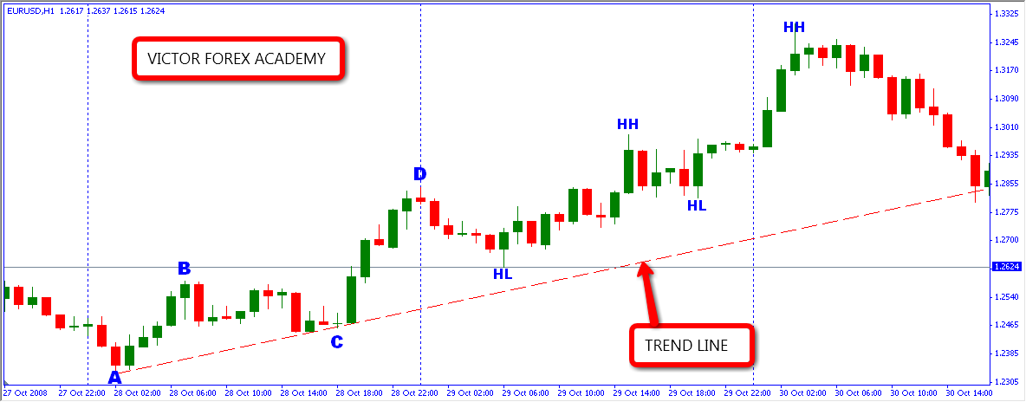
The more A, C and following additional points the line will touch — the more accurately it will work.
AB is the impulsive wave, BC is the corrective wave.

Now do the same thing for a down trend and you have a downtrend trend line

However, having learnt how to spot A-B-C-D points and pulling your TL, there are rules guiding drawing a proper and valid TL

- Point C MUST NOT be lower (in an uptrend) or higher (in a downtrend) than point A

- Point D MUST be higher (in an uptrend) or lower (in a down trend) than point B

Follow these 2 rules and you’ll be able to pull an effective TL from any point in the chart.

- When price opens and closes above a TL, the TL is considered broken.
The implication of this is that, though the TL is still a valid one, the trend
has momentarily stopped and a reversal (major or minor) might be in
place.

- Once a TL has been broken twice, the TL is no longer valid. It should be adjusted and where adjustment is not possible, it should be deleted.

Well, drawing a proper and valid TL can add a major improvement in your forex trading art.

Master this lesson and see how your trading ability will sky rocket.

Wish you all a happy piping.

Victor.
For VICTOR FOREX ACADEMY

